### Definition of Economics

### Economics is the study of how society uses its limited resources. Economics is a social science that deals with the production, distribution, and consumption of goods and services.

### It studies how individuals, businesses, governments, and nations make choices on allocating resources to satisfy their wants and needs, trying to determine how these groups should organize and coordinate efforts to achieve maximum output.

### Economics can be divided in to two segment: - Micro Economics and Macro Economics

### Definition of Micro Economics

Microeconomics is the branch of economics that concentrates on the behavior and performance of the individual units, i.e. consumers, family, industry, firms. Here, the demand plays a key role in determining the quantity and the price of a product along with the price and quantity of related goods (complementary goods) and substitute products, so as to make a judicious decision regarding the allocation of scarce resources, concerning their alternative uses.

**Examples**: Individual Demand, Price of a product, etc.

### Definition of Macro Economics

Macroeconomics is the branch of economics that concentrates on the behavior and performance of aggregate variables and those issues which affect the whole economy. It includes regional, national and international economies and covers the major areas of the economy like unemployment, poverty, general price level, GDP (Gross Domestic Product), imports and exports, economic growth, globalization, monetary/ fiscal policy, etc. It helps in resolving the various problems of the economy, thereby enabling it to function efficiently.

**Examples**: Aggregate Demand, National Income, etc.

**[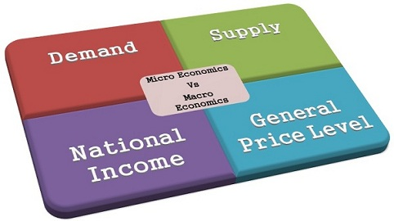](https://keydifferences.com/wp-content/uploads/2014/11/macro-micro-economics.jpg)Difference between Micro and Macro Economics**

The **micro economics** is the study of an economic behavior of a particular individual, firm, or household, i.e. it studies a particular unit. On the other hand, **macro economics** is the study of the economy as a whole i.e., not a single unit but the combination of all, firms, households, nation, etc.

| **BASIS FOR COMPARISON** | **MICROECONOMICS** | **MACROECONOMICS** |
| --- | --- | --- |
| Meaning | The branch of economics that studies the behavior of an individual consumer, firm, family is known as Microeconomics. | The branch of economics that studies the behavior of the whole economy, (both national and international) is known as Macroeconomics. |
| Variables | Individual economic variables | Aggregate economic variables |
| Business Application | Applied to operational internal issues | Environment and external issues |
| Scope | Covers various issues like demand, supply, product pricing, factor pricing, production, consumption, economic welfare, etc. | Covers various issues like, national income, general price level, distribution, employment, money etc. |
| Importance | Helpful in determining the prices of a product along with the prices of factors of production (land, labor, capital, entrepreneur etc.) within the economy. | Maintains stability in the general price level and resolves the major problems of the economy like inflation, deflation, unemployment and poverty as a whole. |
| Limitations | It is based on unrealistic assumptions, i.e. In microeconomics it is assumed that there is a full employment in the society which is not at all possible. | It has been analyzed that 'Fallacy of Composition' involves, which sometimes doesn't proves true because it is possible that what is true for aggregate may not be true for individuals too. |
| Coverage | Microeconomics covers issues like how the price of a particular commodity will affect its quantity demanded and quantity supplied and vice versa. | Macroeconomics covers major issues of an economy like unemployment, monetary/ fiscal policies, poverty, international trade, etc. |
| Deals With | Microeconomics deals with an individual product, firm, household, industry, wages, prices, etc. | Macroeconomics deals with aggregates like national income, national output, price level, etc. |

**Why the study of economics is necessary?**

At present the study of economics is very much important in our life. The necessity of the study of economics is discussed below:

1. Necessary in everyday life of a man: In everyday life man faces lot of wants. But the means of satisfying wants are very much limited. The activities regarding limited wealth with the unlimited wants which are to satisfy is the subject matter of economics. The knowledge of economics is necessary to satisfy unlimited wants through the uses of limited resources.

2. Proper utilization of wealth: Economics gives way to make best utilization of limited resources. We can know from the study of economics how to maximize output of the limited resources and how human welfare can be maximized.

3. Economical: Economics shows how an individual can be economical. Human wants are unlimited. But resources are limited. To satisfy human wants a man has to be economical.

4. Field of production: The knowledge of economics is essential for production. The knowledge of what to produce, how much to produce, what method should be adopted can be understood from the study of economics.

5. Trade and commerce: The knowledge of economics is essential. The market demand of a commodity, the future change of the current demand, and this type of economic knowledge helps to maintain trade successfully. Therefore, the trader or merchants must have the knowledge of economics.

6. Social problem: Most of the social problems are closely related with economic problems. The problem of poverty, unemployment, illiteracy, labor welfare etc. For the proper solution of these social problems the knowledge of economics is must.

7. For labor leader: The leader who deals with labors should have adequate knowledge in economics, in order to conduct labor organization and their claims.

**Basic problems of an economic organization**

Every economy has to solve the following five inter related problems:

(1) What to produce?

(2) How to produce?

(3) How to distribute national Income?

(4) How to ensure growth?

(5) How to ensure proper utilization of scare resources?

These problems are now discussed in brief:

1. What to produce?

The first function of the society is to decide which goods are to be produced and in how much quantity. Since the resources at the disposal of the society are scarce, it has to make a choice between "guns or butter", or a choice between necessities and luxuries. The decision about the allocation of resources between consumer goods and capital goods; their quality and quantity is of utmost importance from the point of view of economic growth.

2. How to produce?

There are various alternative methods or techniques of producing goods. The society has to choose the least cost combination of producing the goods. For instance, cloth can be produced with either handlooms (labor intensive technique) or power looms (capital intensive technique). The society, depending upon its resources and the state of technology available to it should use the most efficient method of production.

3. How to distribute the national income?

The distribution of national income among the members of the community is a burning issue both in the field of economics and politics. The socialists are of the view that all the people should get fair share by redistribution of national income. The other’s view is that, in a in a free enterprise economy, each individual should get his share from the total output of goods according to the income available to him through his genuine efforts.

4. How to ensure growth?

The economic growth can be attained by (a) increasing the rate of investment (b) replacement of capital goods and (c) by improving the technical processes of production. A society, therefore, shall have to take timely decisions for allocating scarce resources for investment, replacement and technological progress. In that case a part of the resources are not diverted for capital accumulation and technological progress then the rate of growth will go down. The standard of living of the people will fall.

5. How to ensure proper utilization of scare resources?

We thus conclude that economic problem arises because of scarcity of resources that people want for the satisfaction regarding goods. The scarcity of resources involves the problems of choice or allocation of resources among the competing ends. Economics, in short, is a science of efficiency in the use of scarce resources.

**Difference between Positive economics and normative economics:**

There are some well remarketed differences between positive economics and normative economics which are discussed below:

1. Positive economics is the pure science regarding what is happening. On the other hand, normative economics is the model science of what ought to be.

2. Positive economics produces fact and data base information which has no relationship with value judgment. Normative economics is a science based on ethics. Therefore, in normative economics good-worse, ought to or ought not to be is highly emphasized here.

3. In positive economics what is fact is preferred most. But in normative economics what ought to be is preferred most.

4. As positive economics depends on the factual analysis and decision is taken on the basis of this type of analysis. But in normative economics decision is taken on value judgment.

5 .In positive economics difference in opinions is rising then solution comes from analyzing the fact and data available. On the other hand in case of normative economics question of personal and social value judgment arises. It cannot be solved through use of data and fact.

6 Sometimes positive economics and normative economics may have mutual opposite position. Therefore, statement of positive economics may not be acceptable to normative economics. On the other hand statement of normative economics may not be acceptable in positive economics.

7. Positive economics deals with how economic problem is solved but normative economics deals with how economic problem should be solved.

**Production Possibility frontier**

Production possibility frontier is the graph which indicates the various production possibilities of two commodities when resources are fixed. The production of one commodity can only be increased by sacrificing the production of the other commodity. It is also called the production possibility curve or product transformation curve.

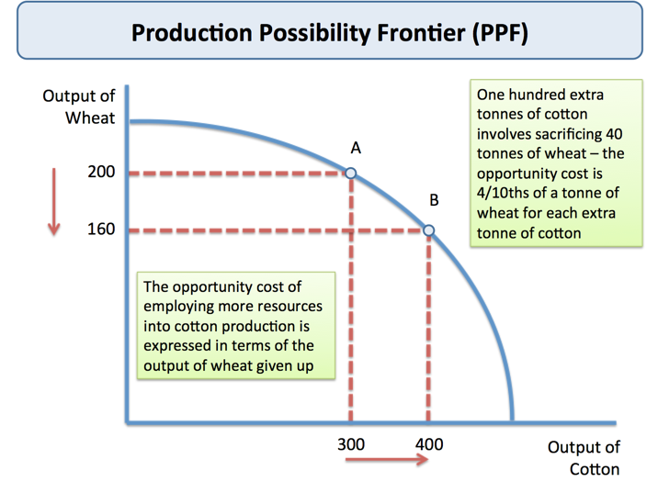

**Law of Diminishing Returns**

The law of diminishing marginal returns states that, at some point, adding an additional factor of production results in smaller increases in output.

For example, a factory employs workers to manufacture its products, and, at some point, the company operates at an optimal level. With other production factors constant, adding additional workers beyond this optimal level will result in less efficient operations.

